

Prepared by: Kimia Sadat Karbasi
Student ID: 60393958
Email: kimia.karbasi@ue-germany.de
Course/No: Software Optimization – P1SO01
Subject: Implementation of Affine Cipher in Python
Professor Name: Dr. Rand Kouatly
Example.No: Task1

Report on
Encryption and Decryption in Python
(Affine Cipher)

Introduction
The Affine Cipher is a type of monoalphabetic substitution cipher that combines modular arithmetic with linear algebra to encrypt and decrypt text. Each character in the plaintext is mapped to its numeric equivalent, encrypted using a mathematical function, and then converted back to a letter. This cipher provides a basic method for secure communication, though it can be vulnerable to brute-force attacks if the key space is small.

Overview
This report presents the implementation of the Affine Cipher in Python, covering 4 phases:

- Encryption: Transforming plain text into ciphertext using a mathematical formula.
- Decryption: Recovering the original plaintext from the ciphertext using an inverse function.
- Brute-Force Attack: Attempting to break the cipher by testing all possible keys
(using a customized dictionary and calculating time)
- Display output

1. Data Encryption

The encryption process in the Affine Cipher follows the formula:

E(x)=(a×x+b) mod26

  - Generating a random “a” value

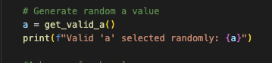
Figure 1 – Generating a random value

    - Adding the gcd function for getting the right value
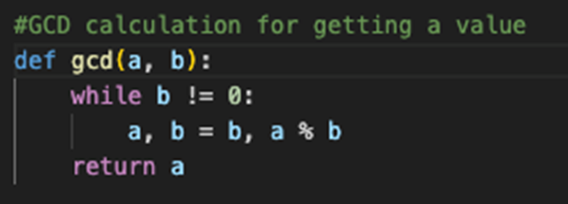
Figure 2 – Adding the gcd Function
1.1.2 Random value
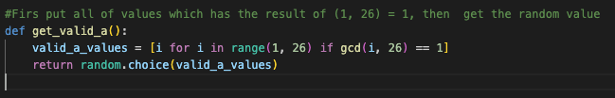
Figure 3 – Random Value

  - Asking User to select the b value between 0 and 25
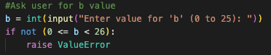
Figure 4 – Selecting b Value

  - Reading Text
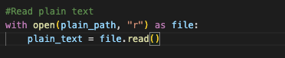
Figure 5 – Reading Text

  - Encrypting the plain.txt (affine_encrypt) by Converting the alphabet to decimal, then adding those to the formula

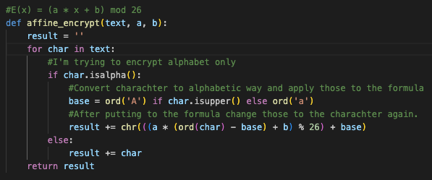

Figure 6 - Encrypting the Plain Text

  - Adding the encrypted data in the cipher.txt
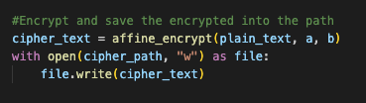
Figure 7- Adding the encrypted data

  - Code Execution

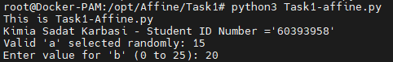

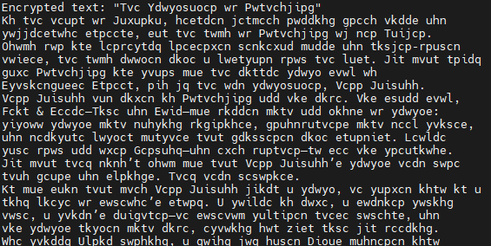
Figure 8 – Executing the Code

2. Data Decryption
The decryption process reverses the encryption formula:
D(y)=a−1×(y−b) mod26
2.1 Decrypting the cipher.txt
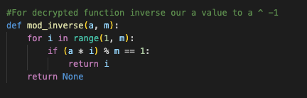
2.1.1 Inverse a value using the created function

Figure 9 – Inverse a value
2.1.2 Reading cipher characters and converting them to decimal for importing into the formula:
D(y)=a−1×(y−b) mod26
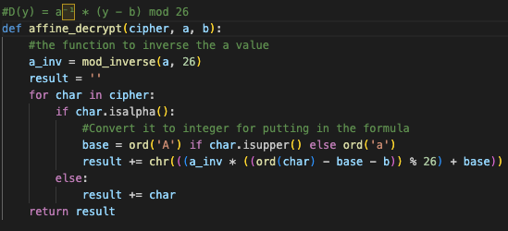

Figure 10 - Converting Cipher Characters

2.2 Adding the decrypted data in the decrypted.txt
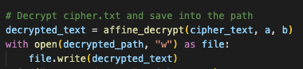

Figure 11 – Adding the decrypted data

2.3 Code Execution

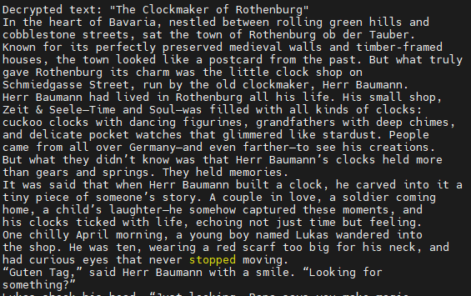

Figure 12- Execution of Code

3. Brute-Force Attack
In this method, the hacker will use the default dictionaries on numerous websites or a custom-generated dictionary. For this implementation, I generate a basic dictionary containing frequently used verbs and words to test the possible decryption outcome. Then we are able to analyze the timing.

3.1 Reading a basic dictionary created by the hacker (no spaces + lowercase)
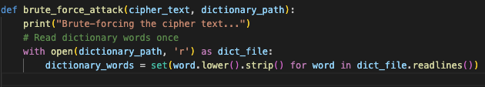
Figure 13 – Reading a basic Dictionary

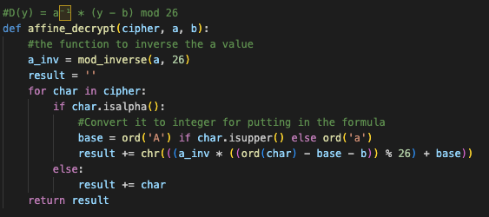
3.2 Using the affine decrypt function to put the values

Figure 14 – Using Affine decrypt function

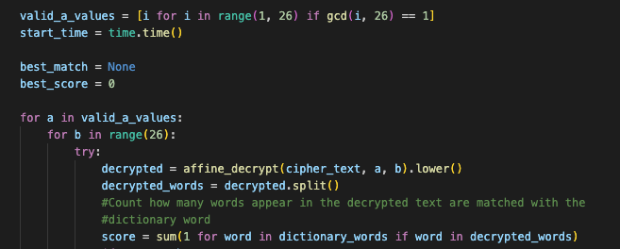
3.3 Counting how many words appear in the decrypted text matches the created dictionary

Figure 15 – Counting words

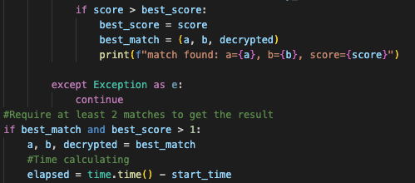
3.4 Finding the correct best_match and best_score

Figure 16 – Finding the correct best_match and best_score

3.5 Writing the unlocked text in the defined path and printing the unlocked text and the time to brute force
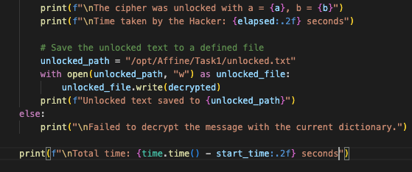

Figure 17 – Code for step 3.5

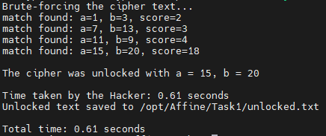
3.6 Execution Code
Figure 18 - Executing the Code

4. Display Output
4.1 Adding the main functions for executing
This part involves defining paths, retrieving the values of “a” and “b”, and reading plaintext to execute the data encryption function. Once the data is encrypted, the decrypted result is saved to the correct path. Finally, the ciphertext is used to perform a brute-force attack.
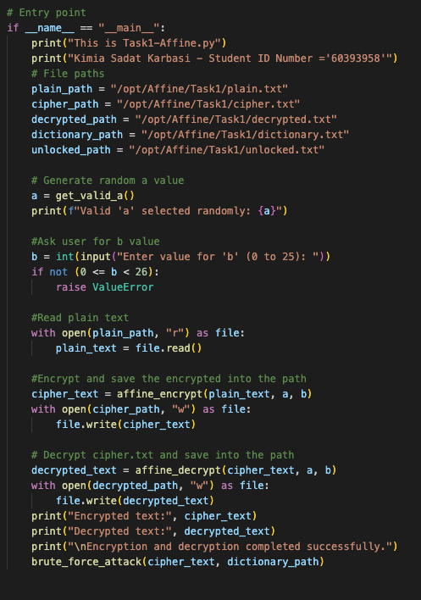

Figure 19 – Adding the main functions to the code

4.2 Display cipher.txt
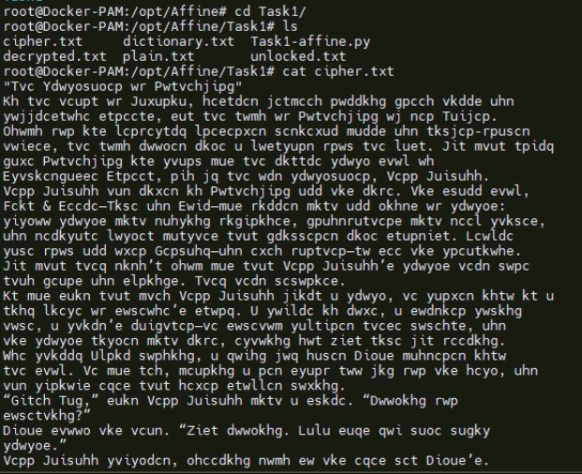

Figure 20 – Display Cipher Text

4.3 Display decrypted.txt

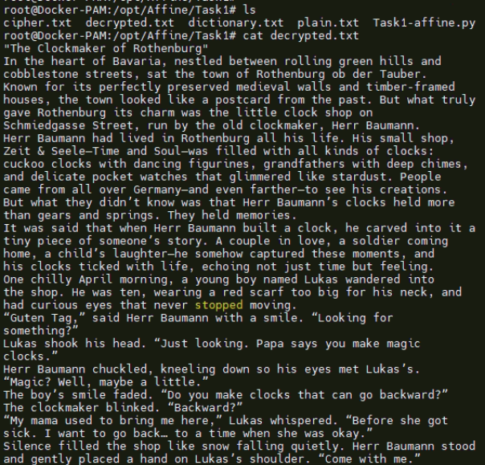

Figure 21- Decrypted Text
4.4 Display a customized dictionary and Brute-Force Attack (unlocked.txt)
We can use numerous dictionaries on websites and use tools for creating a dictionary list. But in this case, we used our own dictionary to get a better outcome.
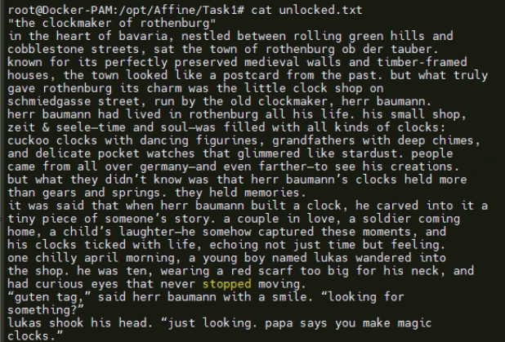
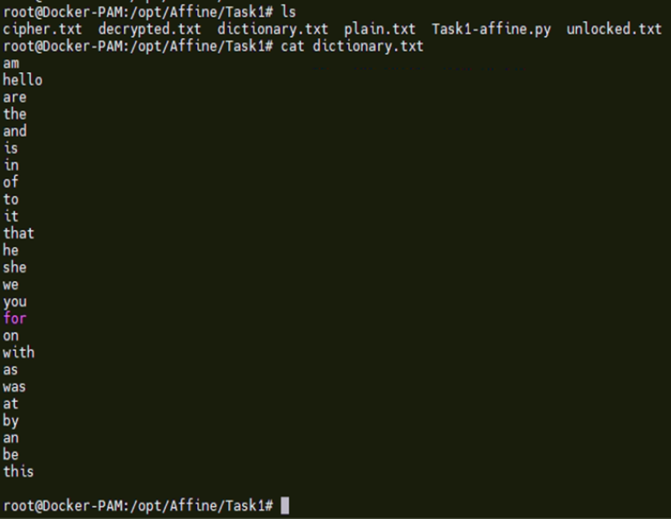
Figure 22 – Code Outcome

Conclusion
This report demonstrated the implementation of the Affine Cipher in Python, covering encryption, decryption, brute-force attack simulation, and output display. The encryption process transformed plaintext into ciphertext using modular arithmetic, while decryption recovered the original message using the inverse key operation. The brute-force attack phase tested the cipher’s vulnerability by systematically checking all possible keys with a created dictionary to measure the execution time.

